**JAVA PRACTICAL LAB 1**

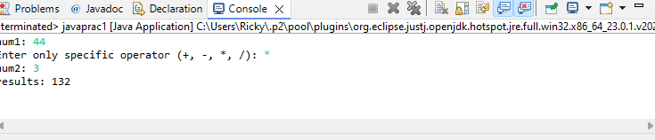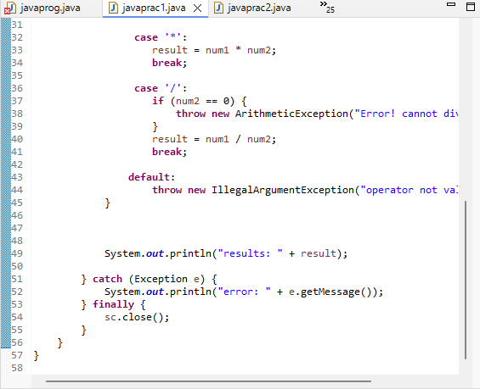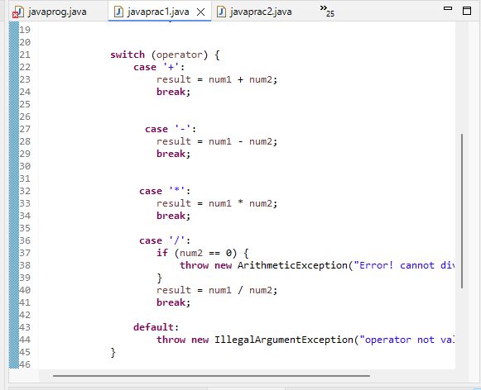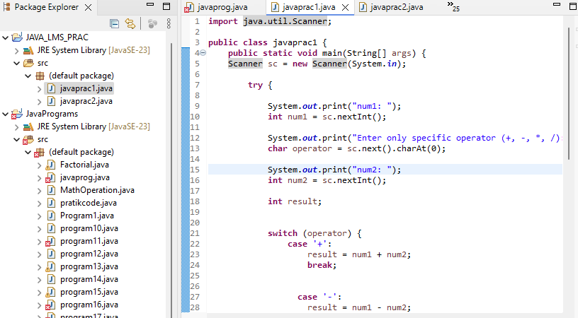  
  
  
**import** java.util.Scanner;

**public** **class** javaprac1 {

**public** **static** **void** main(String[] args) {

Scanner sc = **new** Scanner(System.***in***);

**try** {

System.***out***.print("num1: ");

**int** num1 = sc.nextInt();

System.***out***.print("Enter only specific operator (+, -, *, /): ");

**char** operator = sc.next().charAt(0);

System.***out***.print("num2: ");

**int** num2 = sc.nextInt();

**int** result;

**switch** (operator) {

**case** '+':

result = num1 + num2;

**break**;

**case** '-':

result = num1 - num2;

**break**;

**case** '*':

result = num1 * num2;

**break**;

**case** '/':

**if** (num2 == 0) {

**throw** **new** ArithmeticException("Error! cannot divide by zero");

}

result = num1 / num2;

**break**;

**default**:

**throw** **new** IllegalArgumentException("operator not valid");

}

System.***out***.println("results: " + result);

} **catch** (Exception e) {

System.***out***.println("error: " + e.getMessage());

} **finally** {

sc.close();

}

}

}

**JAVA PRACTICAL LAB 2**

**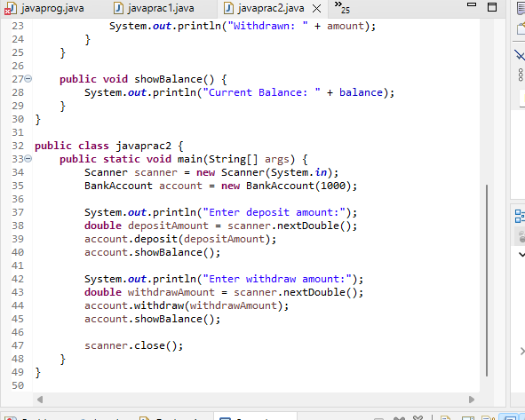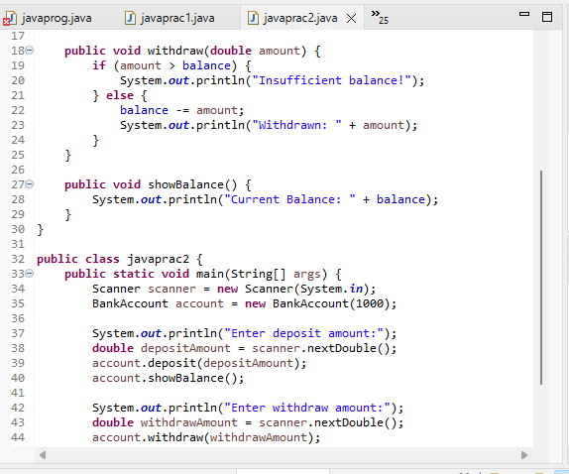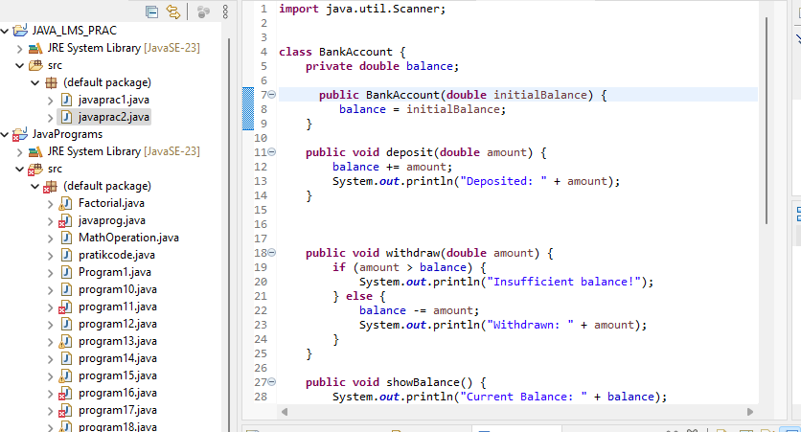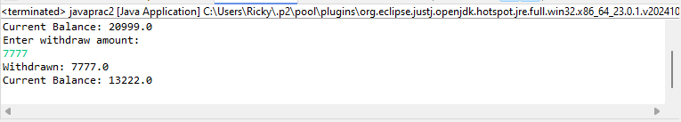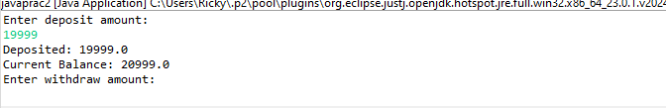  
  
import** java.util.Scanner;

**class** BankAccount {

**private** **double** balance;

**public** BankAccount(**double** initialBalance) {

balance = initialBalance;

}

**public** **void** deposit(**double** amount) {

balance += amount;

System.***out***.println("Deposited: " + amount);

}

**public** **void** withdraw(**double** amount) {

**if** (amount > balance) {

System.***out***.println("Insufficient balance!");

} **else** {

balance -= amount;

System.***out***.println("Withdrawn: " + amount);

}

}

**public** **void** showBalance() {

System.***out***.println("Current Balance: " + balance);

}

}

**public** **class** javaprac2 {

**public** **static** **void** main(String[] args) {

Scanner scanner = **new** Scanner(System.***in***);

BankAccount account = **new** BankAccount(1000);

System.***out***.println("Enter deposit amount:");

**double** depositAmount = scanner.nextDouble();

account.deposit(depositAmount);

account.showBalance();

System.***out***.println("Enter withdraw amount:");

**double** withdrawAmount = scanner.nextDouble();

account.withdraw(withdrawAmount);

account.showBalance();

scanner.close();

}

}